 **ANNA UNIVERSITY** 

**NAAN MUDHALVAN – GUIDED PROJECT**

**SOLUTION ARCHITECTURE**

**CENTRAL BANK SMART CONTRACT**

|  |  |
| --- | --- |
| DATE | 31 OCTOBER 2023 |
| TEAM MEMBERS | 1. NAVEEN PRASAD R S 2. NIKITA R 3. PARITHIELAMVAZHUTHI V 4. PRASANTH M |
| PROJECT NAME | CENTRAL BANK SMART CONTRACT |
| COLLEGE NAME | ALAGAPPA COLLEGE OF TECHNOLOGY, ANNA UNIVERSITY |

**Solution Architecture:**

The Central Bank Smart Contract is a sophisticated blockchain-based solution designed to enhance the efficiency and transparency of central bank operations. Leveraging a permissioned blockchain, this architecture ensures secure and tamper-proof record-keeping of monetary policies, transactions, and regulatory compliance. The smart contract automates key central banking functions, such as monetary issuance, interest rate adjustments, and financial market operations, in accordance with predefined rules and regulations. It interfaces with various stakeholders, including commercial banks, government agencies, and financial institutions, to facilitate real-time data sharing and regulatory enforcement. With robust encryption and consensus mechanisms, this architecture ensures the integrity of the central bank's operations, promoting trust and reducing operational risks within the financial ecosystem.

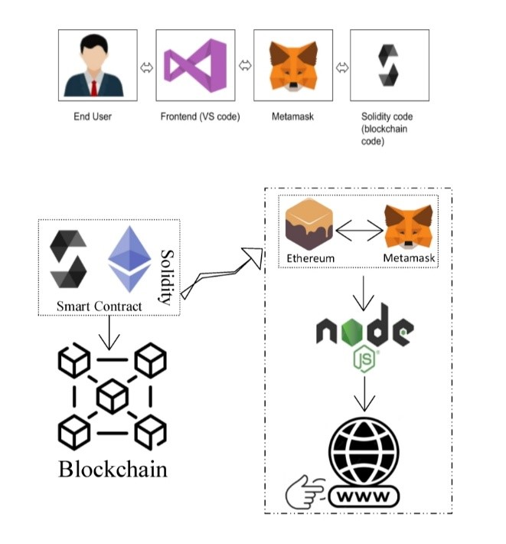

Schematic Diagram of Solution Architecture

Prerequisite:

1. download node.js : Node.js
2. download vs code: Li4nk
3. download metamask : https://metamask.io/

Steps to complete the project

Step 1:-

1. Open the Zip file and download the zip file.

2. Extract all zip files

Step 2 :

1.Open vs code in the left top select open folder. Select extracted file and open .

2. Select the projectname.sol file and copy the code.

3. Open the remix ide platform and create a new file by giving the name of projectname.sol and paste the code which you copied from vs code.

4. Click on solidity compiler and click compile the projectname.sol

5. Deploy the smart contract by clicking on the deploy and run transaction.

6. select injected provider - MetaMask. In environment

7. Click on deploy. Automatically MetaMask will open and give confirmation. You will get a pop up click on ok.

8. In the Deployed contract you can see one address copy the address.

9. Open vs code and search for the connector.js. In contract.js you can paste the address at the bottom of the code. In export const address.

10. Save the code.

Step 3: open file explorer

1. Open the extracted file and click on the folder.

2. Open src, and search for utiles.

3 . You can see the frontend files. Select all the things at the top in the search bar by clicking alt+ A. Search for cmd

4. Open cmd enter commands

npm install

npm bootstrap

npm start

5. It will install all the packages and after completing it will open {LOCALHOST IP ADDRESS} copy the address and open it to chrome so you can see the frontend of your project.